URP Lighting with Café Model
Synopsis and additions to the following video tutorials for the Café model (or other Assets):
https://www.youtube.com/watch?v=7YzWexOAggc
https://www.youtube.com/watch?v=vmwdKK-GZDc
- Create new Unity Project – Universal 3D (URP)example template
https://gyazo.com/a845d1532b58fea1236a7a273763a7f8
- Or To convert existing Built-In(Standard) 3D project to URP:
  - https://youtu.be/KpTK-OraZ-g
  - In Existing project, Import Universal RP package from Unity Registry in Package Manager
  - Right Click in Project window – Greate Rendering/URP Asset with Universal Renderer
  - Edit/Project Settings/Graphics/Select the URP (Universal Render Pipeline Asset you created above
  - Convert materials: Window/Rendering/Render Pipeline Converter/
    - Select Built in to URP
    - Tick Rendering Settings
    - Tick Material Upgrade
    - Press Initialise Converters
    - Click Convert assets
https://gyazo.com/392021fb49a5699f4d460dff371965ab
  - Trouble shoot individual materials with change from Standard to URP in Inspector
  - In a URP Project with some Pink (Standard) Materials, convert a range of standard materials to URP by Can convert material from standard to URP by selection in hierarchy and selecting: Top Menu/Edit/Rendering/Materials/Convert Selected Built in Materials to URP
- Create new Scene: Standard URP (Has Global Volume)
https://gyazo.com/16081b90e34d96d6a0cabf2d55c1e533
- Import Café model – extract Textures and Materials to created folders
- Drag Café model into new scene
- Open and Check Lighting tab (Top Menu/Window/Rendering/Lighting) - Create New Lighting Setting from Button “New” at the top of the lighting window
- Enable Baked Global Illumination under Mixed Lighting, and baked Indirect in the Lighting Mode drop down box
- Enable Auto Generate at bottom of page – this eliminates the black shadows by using ambient light from the skybox
https://gyazo.com/cddb73d6d436fbd4b4333432d55587ea
- Go to Edit/Project Settings/Player/Other Settings – change color space to Linear
- In Edit/Project Settings/Quality/Rendering/RenderPipelineAsset - check - should be URP-HighFidelity (Universal Render Pipeline Asset)
- In the Inspector/Directional Light – rotate to 30,-150,0 or to taste
- In Lighting Window – Environment Tab, test effects of using color rather than Skybox
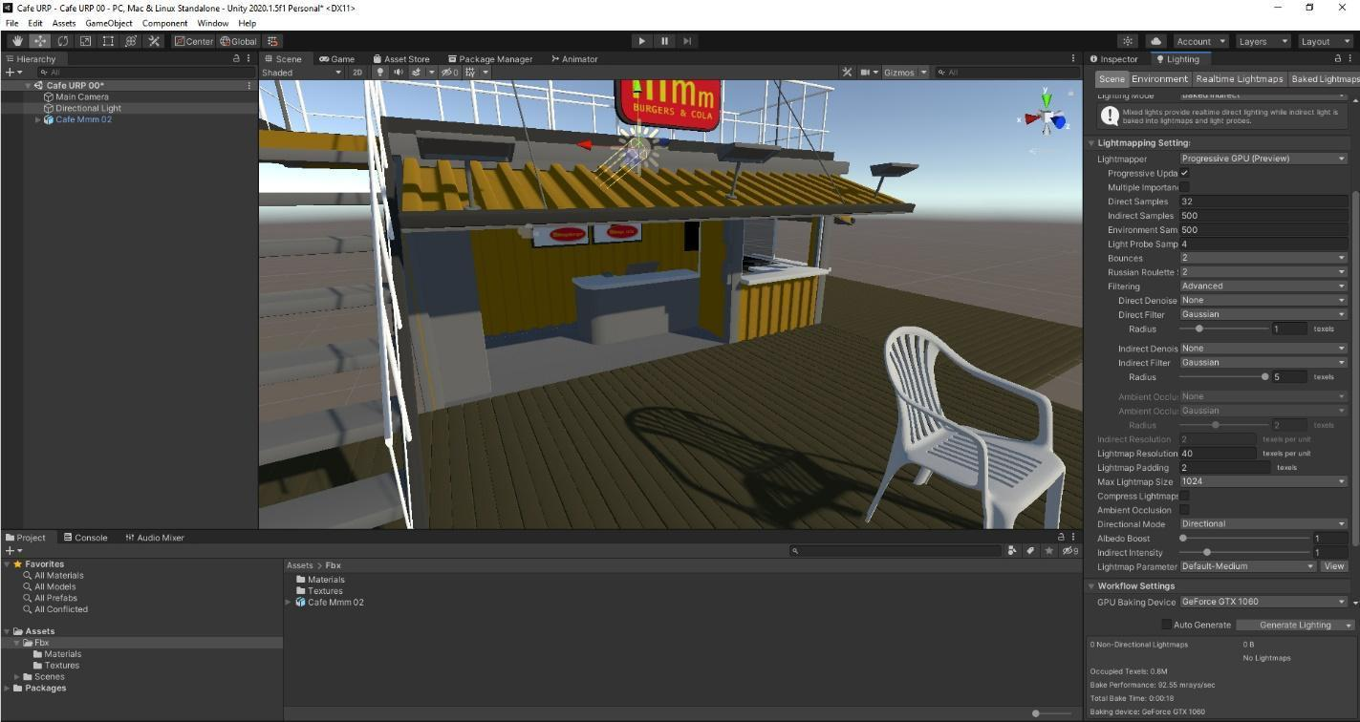
- Baking Indirect Light:
  - Lighting/Scene – Untick Auto-Generate at bottom
  - Lighting mode: Dropdown box to to Baked Indirect
  - Lightmapper: Dropdown box to Progressive GPU
  - Lightmap Compression: Dropdown box to None
  - In Hierarchy, Inspector, make Café Static (and children)
  - In Hierarchy, Inspector, Directional Light –
    - Mode: Dropdown box to Mixed
    - Shadows/Realtime Shadows/Bias: dropdown box to Custom, zero out
  - In Lighting Window – clear baked data (recalculate Environment), then “Generate Lighting”
  - This is Baked indirect lighting with real time shadows.

- Add Fog
  - Lighting Window/Environment/ Tick Fog
  - Select Linear in Mode drop down box
  - Set start to 5, end to 150
  - Pick color
- Post Processing Setup - Camera
  - No Post Processing layers or setup needed with URP
- Post Processing Setup – Global Volume
  - No Post Processing Volume setup needed with URP
    - Just make sure Global Volume in Hierarchy is active and its component Volume/Mode is Global
    - Can adjust Weight of overall effect
    - Check it has profile
    - If you don’t have a Global Volume, add it from top Menu/Game Object/Volume/Global Volume
    - Create new Volume Profile in Inspectore window for Global Volume

https://gyazo.com/75a4c1851dfc5814e20ab17184c3114a
  - Just Add Overrides for Options
    - Defaults are Tonemapping, Bloom
    - Tick to activate needed settings and adjust
    - Suggested Overrides:
      - Ambient Occlusion
      - Depth of Field
      - Motion Blur
      - Vignette
  - For Glow/Emission –
      - Check HDR in Main Camera (may be in First Person Character) is set to “Use Settings from Render Pipeline Asset”
      - Create a Dark Skybox
        - Create Material
        - In shader dropdown select Skybox/Procedural
        - Adjust down Sun Tint, Atmosphere Tint
        - Take HDR exposure down to .3
        - Drag into Lighting/Environment/SkyboxMaterial box to replace old Skybox Material
        - Adjust Directional light Color down in Hierarchy to taste
        - Select Café Railings and adjust material to less than 100% White
      - Add Bloom to Volume
        - Try adjustments above 1 for intensity, and about .8 for threshold
        - You will have to adjust the Skybox and some materials to not be pure white, so they do not bloom
        - You can now add objects with Emission materials for glow.
      - Glow - Create Cube with Emission Material
        - Create Material
        - Tick Emission
        - Below Emmission select Color Picker box nest to Emmission map tickbox, Pick HDR color to be bright
        - In same color picker select intensity to be 1 or above
https://gyazo.com/7227f3ff142b59f2bdb258c4894d9650
https://gyazo.com/130512b57e52f937ed39a92fa3e49f2f
      - At this point you will want to rethink your Directional Light(s) and Rebake!
      - Try it with the actual Light objects....

    - References for Bloom
      - https://www.youtube.com/watch?v=bU1sBNfbdM4
      - https://youtu.be/WiDVoj5VQ4c
      - https://www.youtube.com/watch?v=czE2oLyrNLM
Troubleshooting (Settings to check):
- Top Menu/Edit/Project Settings/Quality/Current Active Quality Level = High Fidelity
- Top Menu/Edit/Project Settings/Quality/Rendering/Render Pipeline Asset = URP –HighFidelity(Universal Render Pipeline Asset)
- Window/Rendering/Lighting/Scene/Lighting Settings/Lighting Settings Asset = “LightingSettingYouMade”(press New)
- Window/Rendering/Lighting/Scene/Mixed Lighting/Realtime Global Ilumination = off
- Window/Rendering/Lighting/Scene/ Mixed Lighting /Baked Global Ilumination = on
- Window/Rendering/Lighting/Scene/Lightmapping Settings/Lightmapper = Progressive GPU
- Window/Rendering/Lighting/Scene/Lightmapping Settings/AutoGenerate = off (press Generate Lighting as needed)
- Hierarchy/Post Process Volume/Global Volume/Profile (“SampleProfile or ProfileYouMade”(press New)
- Hierarchy/Global Volume/Overrides as desired...
- Hierarchy/Global Volume/Mode/Global
- Hierarchy/Global Volume/Profile/Make new one – click “New” Button
- Check URP Renderer: Top Menu/Edit/Project Settings/Graphics/ Scriptable Render Pipeline Settings:
  - URP-HighFidelity (Universal Render Pipeline Asset)
- Check URP Renderer: Top Menu/Edit/Project Settings/Graphics/URP Global Settings:
  - UniversalRenderPipelineGlobalSettings (Universal Render Pipeline Global Settings)
- Settings - How to Fix Pink Materials in Unity 2023 | Render Pipeline Basics
Stretch Targets:
- Import camera from week 11 or Starter Assets for FPC/3PC
- Try different skyboxes – 1 color, panoramic
https://gyazo.com/dc98d7c204568ff2b0c7df53ae614f19
- Make Light Probes for moving lights
- URP Converting and Pink Material troubleshooting:
  - Create new Unity Project – URP example template
  - To convert Standard to URP:
    - https://youtu.be/KpTK-OraZ-g
    - In Existing project, Import Universal RP package from Unity Registry in Package Manager
    - Right Click in Project window – Greate Rendering/URP Asset with Universal Renderer
    - Edit/Project Settings/Graphics/Select the URP (Universal Render Pipeline Asset you created above
    - Convert materials: Window/Rendering/Render Pipeline Converter/
      - Select Built in to URP
      - Tick Rendering Settings
      - Tick Material Upgrade
      - Press Initialise Converters
      - Click Convert assets
    - Trouble shoot individual materials with change from Standard to URP in Inspector
      - Materials: Edit/Rendering/Materials/Convert to URP
      - Materials: Adjust materials by hand in inspector to Shader: URP/Complex Lit
      - How to Fix Pink Materials in Unity 2023 | Render Pipeline Basics

Stretch Targets - Camera (3PC or FPC from Starter Assets):
- Add Standard Assets
  - https://jimmyvegas.itch.io/standard-assets
- Add FPC Prefab to Hierarchy
  - Window/Package Manager
  - Select top left drop down for My Assets
  - Add downloaded Starter Assets - First Person Character Controller
  - Disable old Main Camera
  - Rotate and move Player Capsule to face the Cafe
  - Test by playing.

